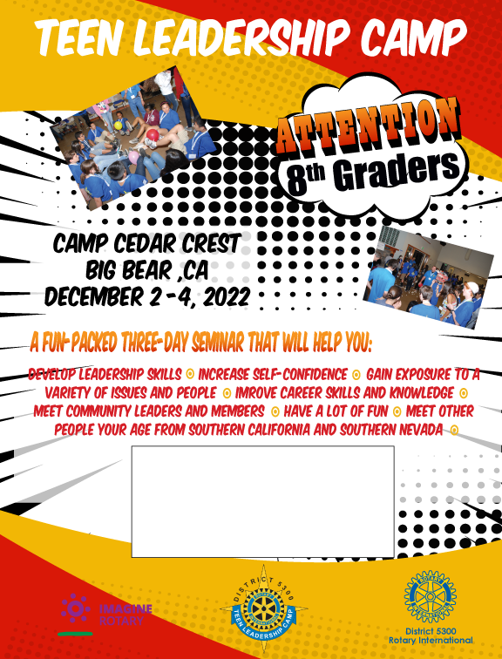

This is a text box. You may input your club contact info in this box. The main image is a .jpg and not editable.