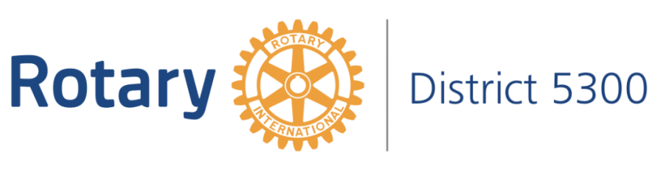

ROTARY 4-WAY TEST SPEECH CONTEST 2021-22

Student Speaker Biography

Name:

Email Address:
(please print clearly)

Name of High School:

Current Grade Level:
School Contact Person:

The following information is not required but it is helpful should we need to contact you about the 4-Way Test Speech Contest.

Parent(s) or Guardian:

Contact Number:

Mailing Address:

Describe some of your interests (hobbies, sports, goals, special talents, college plans etc.)

Office use only:

Representing Rotary Club: ____________________

