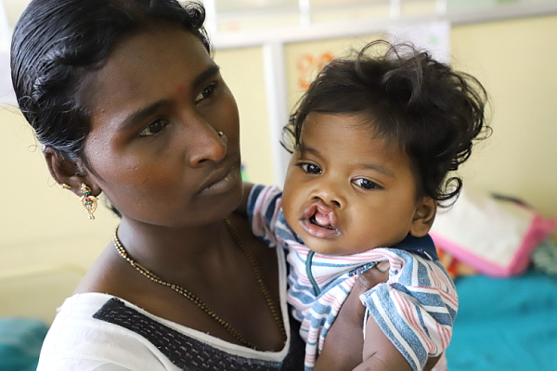

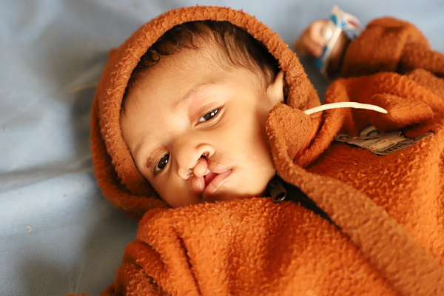

District 5300’s Rotaplast Mission to Chitwan, Nepal
March 21 – April 4, 2021

Each year thousands of children are born with cleft lip and cleft palate anomalies. During the past nine years District 5300’s clubs and individuals generously raised the funds for six medical missions: two to Retalhuleu, Guatemala; one to Monrovia, Liberia; and one to Lima Peru; one to Arusha, Tanzania; and one to Agra, India. 28 district Rotarians have volunteered their time to support the medical staff on one or more of these two week missions. Because of their efforts, individual contributions, and our clubs’ financial support, over 504 medical procedures have been performed on 415 patients during our sponsored missions. We have changed lives.

The District Rotaplast Committee and Governor-elect Greg Jones have decided to co-sponsor a seventh Rotaplast mission. We will send a team to Chitwan, Nepal, where there is a significant need related to cleft lip and palate surgeries and burn scars surgical reconstructions. Depending on the state of the COVID-19 pandemic, the mission has been tentatively been scheduled to take place between March 21 – April 4, 2021.

We will partner with the Rotary Club of Chitwan which will provide the in-country support, publicize the mission in the surrounding communities, search out and find patients, and work side-by-side with our team. A full team typically consists of 22 medical and 10 non-medical volunteers. The committee will recommend 5 non-medical Rotary volunteers from our district as participants. Volunteers from past missions are available to present club programs.

We seek your support for this district-sponsored mission. We have been fortunate to be the recipients of funds from the Welles’ Family Foundation through the Rotary Club of Las Vegas. These funds will provide seed money for this mission. Our goal this year is to raise an additional $30,000 from Rotary clubs, Interact/Rotaract clubs and individual Rotarians and friends. We request that each club consider a contribution to this cause and encourage a member to apply as one of our 5 non-medical volunteers.

Donation and volunteer application forms are on the district webpage: https://district5300.org/service/international-service/rotaplast/ .Contributions should be made payable to “Rotary District 5300 Foundation” with “Rotary Cleft Lip Project” clearly written on the memo line and then sent to Rotary International District 5300, 10624 S. Eastern Ave., Ste A-16, Henderson, NV 89052. We appreciate contributions be made by January 15, 2021.

Rotaplast International is a 501(c)(3) non-profit, humanitarian organization founded in 1992 as a world community service project of the Rotary Club of San Francisco by two Rotarians Dr. Angelo Capozzi and Peter Lagarias. Rotaplast is committed to changing lives through reconstructive surgery, and since that date has performed over 20,700 surgeries in 26 countries around the world, averaging a dozen missions a year. It has received a 4 Star Rating (the highest) by Charity Navigator.

QUESTIONS: Roger Schulte, Co-chair, rogerschulte@gmail.com 909-532-0673
Robin Smith, Co-Chair, redzlife2@yahoo.com 702-460-5080
Tony Scheppmann, tncscheppmann@gmail.com 702-460-5723
Drexel Smith, drexel.smith@drexelconsultinggroup.com 951-202-2012

