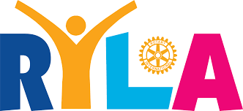

Sample Letter of Selection

Rotary Youth Leadership Award

Name
Address
City, State ZIP

Re: Rotary Youth Leadership Conference – RYLA

Dear __________________,

Congratulations! I am writing to inform you that you have been selected to
attend the Rotary Youth Leadership Award Camp (RYLA) March 20-22,
2020 at Camp Cedar Crest in Running Springs, California.

The Rotary Club of _____________________ is sponsoring you and will pay all
your expenses relating to transportation, lodging and meals. In addition, you and
your fellow “RYLArians” are invited to a Rotary Club meeting scheduled for
______________________at _________ at the ___________________,
where you will have an opportunity to meet other Rotarians and learn more about
Rotary.

Further details about RYLA will be provided to you and your parent(s) at
an orientation meeting scheduled for ___________________2020__ at
_____ at the __________ at ____________________,
_________________. This meeting will also include RYLArians sponsored by
the ____________________ and _____________ Rotary Clubs. Your
attendance is mandatory and crucial to your full participation and will allow you
and your parent(s) to ask questions and gain a clearer understanding of the RYLA
Conference.

We hope that you will make the most of this learning opportunity. We want to
thank you for participating in the application process.

Sincerely,

RYLA Chairperson

