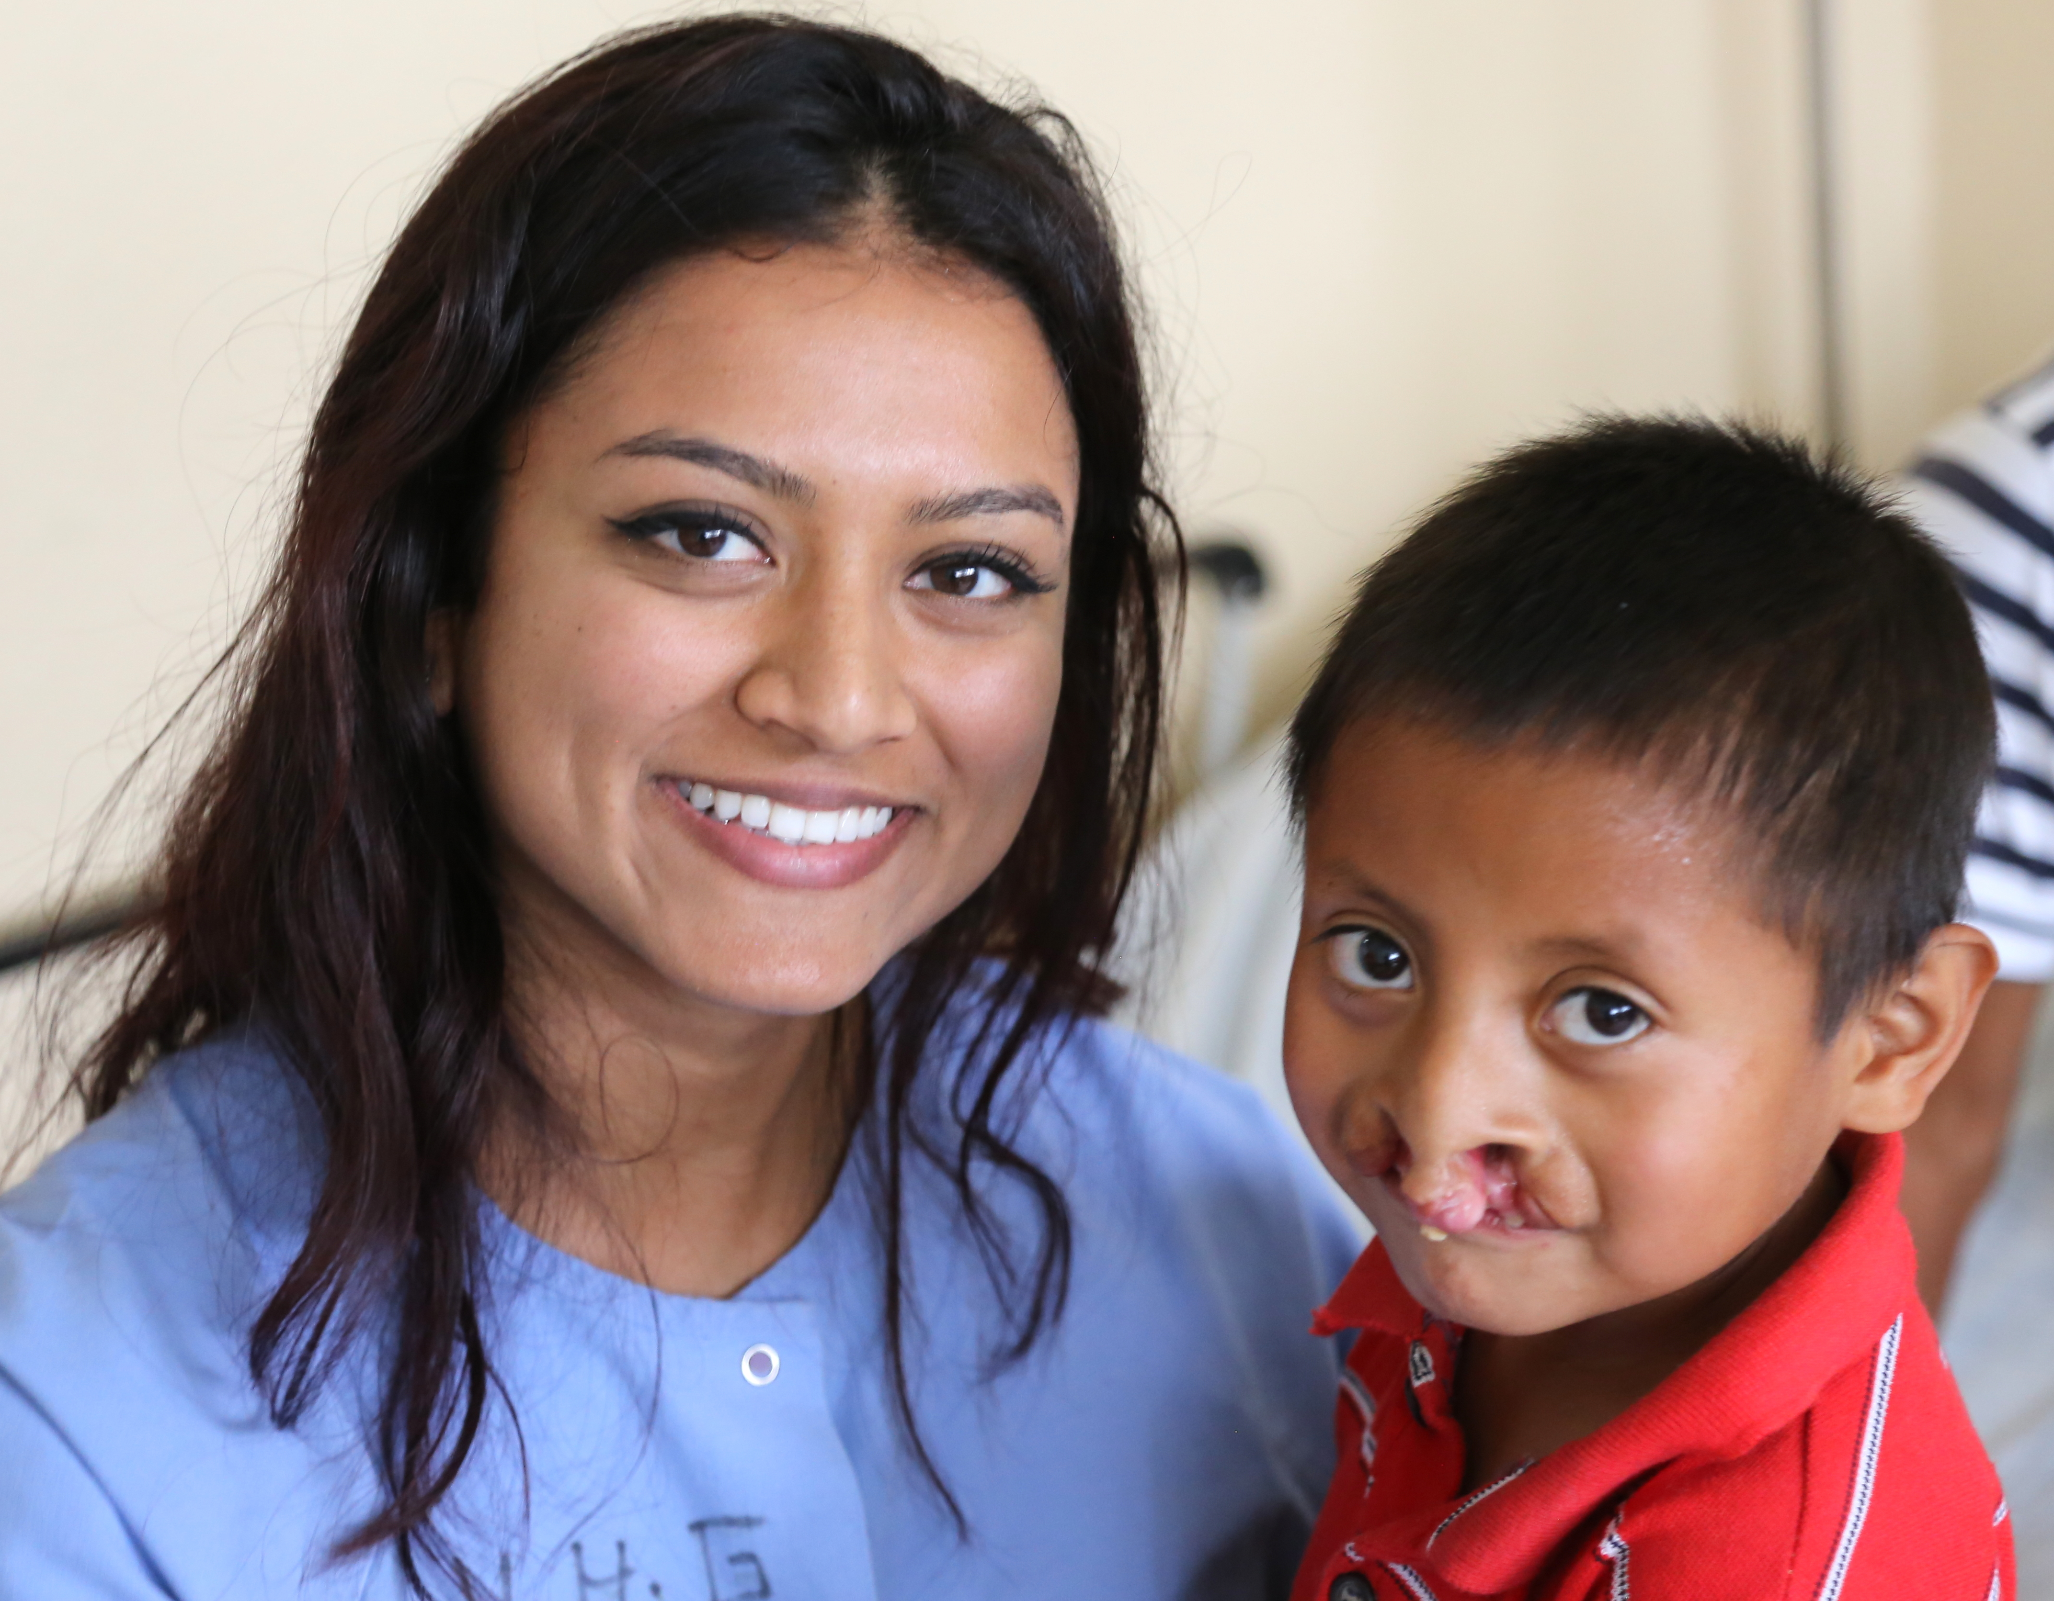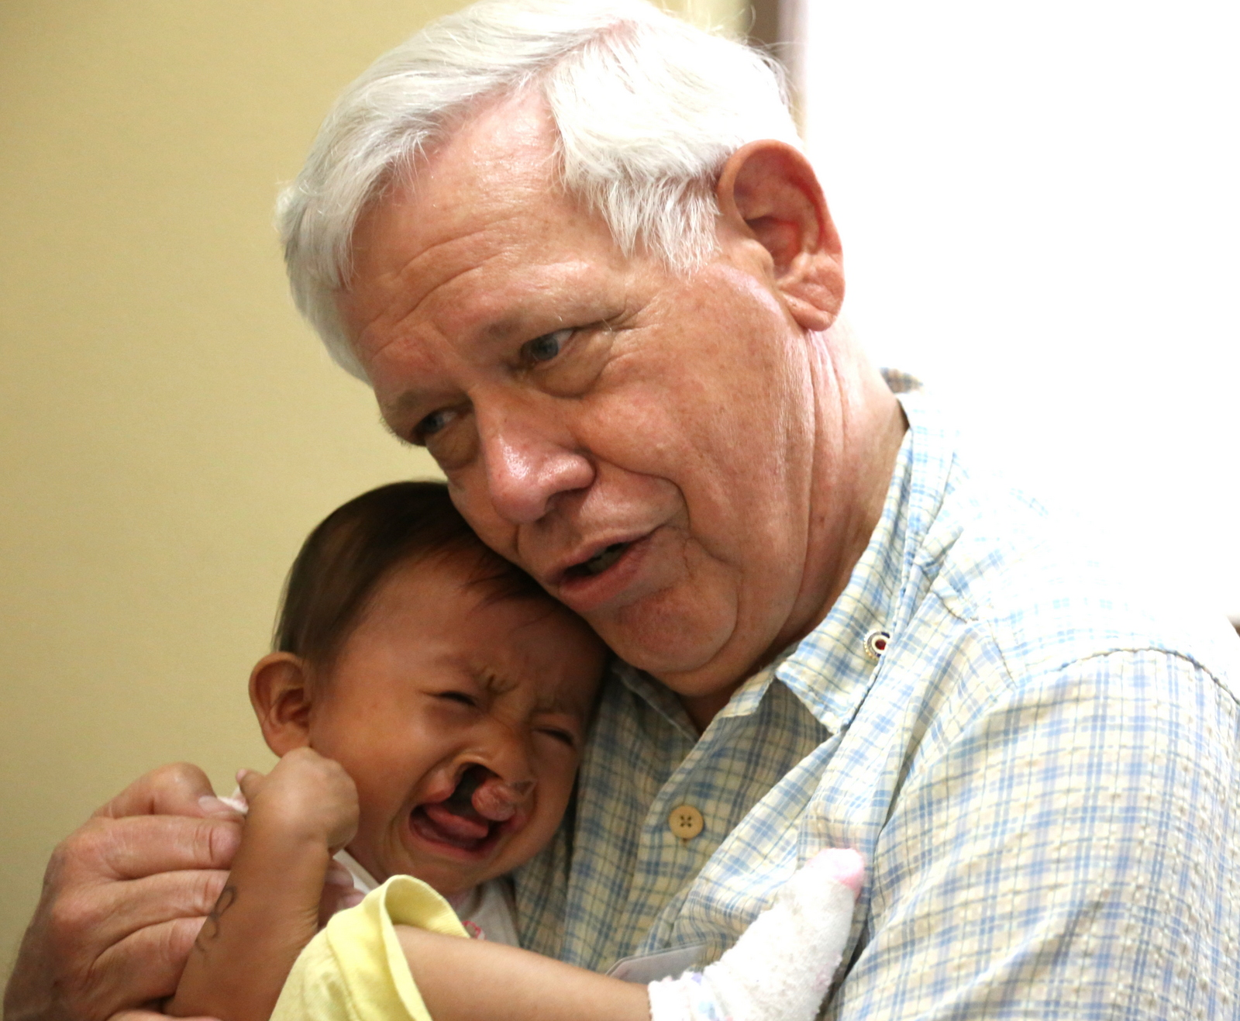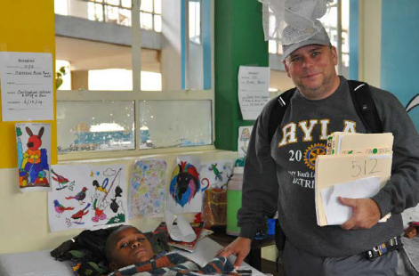
Volunteer for District 5300’s Rotaplast Mission
Agra, India
February 23 – March 8, 2020
NON-MEDICAL VOLUNTEER INTEREST FORM

Rotarians/Rotaractors from District 5300 will be needed to fill 5 non-medical volunteer positions. Individuals interested in volunteering as non-medical volunteers should contact Roger Schulte, review the Rotaplast website: www.rotaplast.org, complete this form, and return it along with a personal statement by November 15, 2019, to Roger Schulte. (At this point do not complete the non-medical volunteer form on the Rotaplast website.)

Name of Interested Volunteer: | Name of Rotary/Rotaract Club:
Volunteer Address:
Email: | Phone:

Non-medical volunteers should accompany this interest form with a short personal statement (no longer than 250 words) which addresses: Why they might be interested in joining a Rotaplast team and what skills they would bring to the team. These positions will be filled by active District 5300 Rotarians/Rotaractors. Selection will be based on team compatibility and skills needed for the mission. Those who have never been on a Rotaplast mission are encouraged to apply. There will be a tour of the Taj Mahal and extended personal travel at the conclusion of the mission is possible. Travel costs arranged through Rotaplast is the responsibility of the non-medical volunteer. Medical volunteers should also contact Roger Schulte.

Questions: District 5300 Rotaplast Committee
Roger Schulte, Co-chair, rogerschulte@gmail.com 909-532-0673
Robin Smith, Co-chair, robin@smithteamlasvegas.com 702-460-5080
Tony Scheppmann, tncscheppmann@gmail.com 702-460-5723
Drexel Smith, drexel.smith@drexelconsultinggroup.com 951-202-2012

