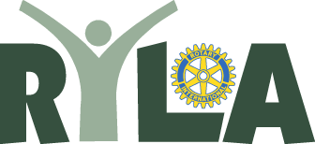
Sample Letter to School Announcing Student Selection

Rotary Youth Leadership Award 2019

Name
Address
City State ZIP

Re: RYLA Selections for 2019

Dear ______________________,

The following _________________ High School students have been
selected to represent the Rotary Club of ___________________ at the
Rotary Youth Leadership Award Conference (RYLA) on March 29-31, 2019 at
Camp Cedar Crest in Running Springs, California.

We will be inviting you and your students to a club meeting scheduled for
________________ at ________ at the _____________________ to
introduce the young people to the Rotarians sponsoring them for this three day
conference.

You are also invited to attend an orientation meeting on
__________________2019 at _________ at the
____________________ at _________________________. This will
include the participants sponsored by the _______________ and
_______________ Rotary Clubs, and will provide you a clearer
understanding of the events of the RYLA Conference.

Thank you for your help and input, it has been invaluable in the selection
process.

Sincerely,

RYLA Chairperson

