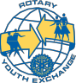
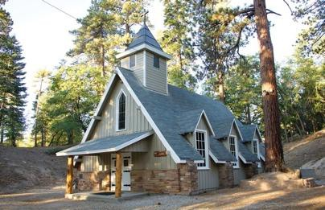
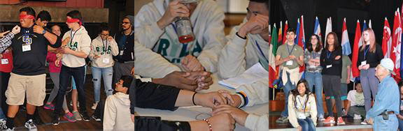
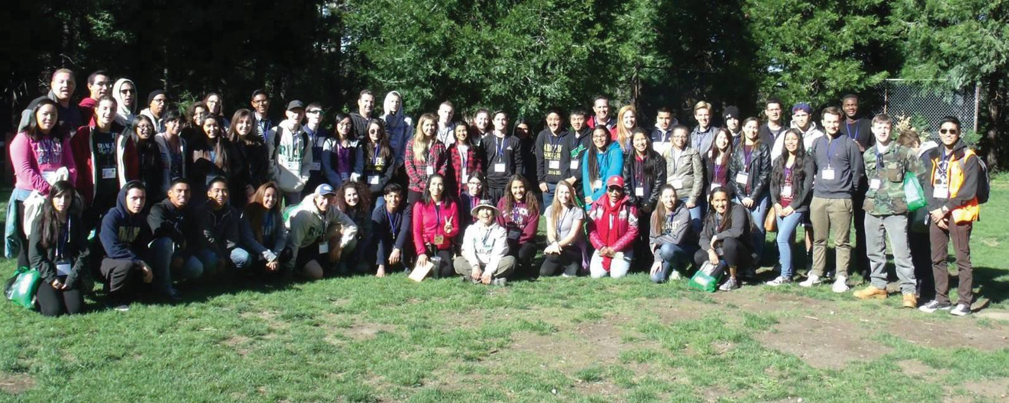
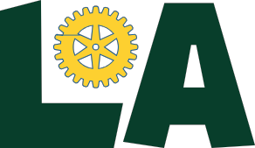

YOURLIFE?
Attention 10th & 11th graders!

March 29-31, 2019 graders!

WHAT IS RYLA
Rotary Youth Leadership Awards (RYLA) is an intensive training program for High School Sophomores and Juniors. Talented young people attend a 3 day seminar organized by the Rotarians of District 5300 of Rotary International. All of the participants’ expenses are often paid by sponsoring Rotary Clubs
WHAT DOES RYLA OFFER
Develop Leadership Skills Increase Self Confidence
Gain exposures to a variety of issues & people Improve career skills & knowledge
Meet community leaders & members Have a lot of fun
Meet Other People Your Age from
Southern California & Southern Nevada
WHO PARTICIPATES IN RYLA
RYLA events are for young adults with proven leadership experience and potential leaders from diverse backgrounds. If you are a High School Junior you will learn, grow, have fun
and make friends.
The RYL A experience prepares young people to be leaders in their community, profession, and other facets of life.

