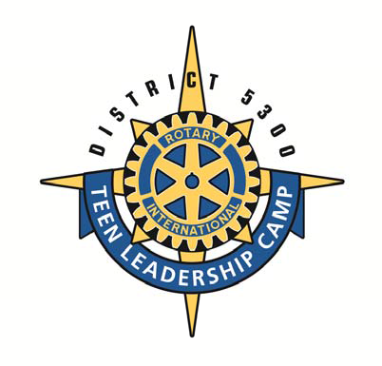
Teen Leadership Camp

Rotary District 5300
Parental Consent for Participation & Medical Treatment November 30th-December 2nd, 2018

Please print or type. Illegible application may be disqualified

EXCHANGE STUDENT APPLICATION
Submit to Meg Ryan @ Mryan@afncorp.com

Please print legibly or type Please complete ALL items Parent/Guardian MUST sign!

Student’s Name: | Name for Badge: |  | Circle T-Shirt Size Adult: S, M, L, XL
Address: | Sex: | Date of Birth: |  | Age:
City: | State: | ZIP:
Parent/Guardian’s Name: | Parent’s 24 Hr. Phone ( )
Parent/Guardian’s Address (if different from above): | Home Number ( )
Alternate Contact Name: | Alt. Phone Number: ( )
Name of Medical Insurance Company: | Policy Number: ( )
Physician’s Name: | Phone Number: ( )
School Name: | Phone Number: ( )
Email Address: Student Email Address: Parent
Please list any problems, allergies or medical conditions of which we should be aware: Are you allergic to insect stings, do you have an insect sting kit (e.g. EppiPen)? Any food allergies? If none please indicate N/A
Do not leave blank
Please list any prescription medications, with dosage and frequency which the student is using or might need:
N/A if none
Do not leave blank
Sponsoring ROTARY CLUB: RETURN BY November 9th, 2018

Name of Student: ___________________________

PARENTAL/GUARDIAN AUTHORIZATION; I do voluntarily consent to said minor’s participation in all activities of the Teen Leadership Camp (TLC) to be held at Camp Cedar Crest December 1-3, 2017. I understand that this leadership camp could involve physical activities including elevated rope apparatus high off the ground. Although these activities are well supervised by adults there is always an inherent risk of physical injury to the participant and I’m willing to have my child participate.
Initial: ______
MEDICAL TREATMENT RELEASE: I assume responsibility for any medical or treatment/transport fees or costs incurred directly or indirectly because of said minor’s participation. I also authorize the representative(s) of Rotary District 5300, and Camp Cedar Crest to arrange for professional care and treatment in case of medical emergency. I hereby give permission to the physician selected by the Rotarian(s) or Camp Cedar Crest to hospitalize secure professional treatment for and/or to order injections, anesthesia and/or surgery for the minor named above.
Initial: ______
INDEMNIFICATION/HOLD HARMLESS:
In consideration of the Rotary Club, Rotary District 5300 and Camp Cedar Crest, I permit this minor to participate in Teen Leadership Camp (TLC) and to engage in all activities related to the weekend program. I hereby assume the risk associated with participation & agree to hold the Rotary Club, Rotary District 5300, and Camp Cedar Crest, its committees, employees, as agents, as representatives, and volunteers harmless from any and all liabilities, actions, causes of action, claims or demand of any kind & nature whatsoever which may arise by or in connection with said minor’s participation in any activities related to the Teen Leadership Camp (TLC). The terms here shall serve as a release & the assumption of the risk for said minor, his or her heirs, estate, executor, administrator, and assignees as well as members of the family.
Initial: ______
I also take full responsibility for any valuables that the above named participant takes to this camp, that could get lost or stolen and I am fully aware I have been advised that said minor should not bring any valuables. I hereby give permission for Rotary to post pictures of said minor participating in this event in Rotary publications including on its websites, social media, presentations, etc..
Initial: ______
I further consent to permit authorized Rotarians to contact said minor after the Teen Leadership Camp (TLC) with respect to other Rotary programs and activities.
Initial: ______
A photocopy of this form is as valid as the original.
Initial: ______

Parent/Guardian’s Name: PRINT | Signature: | Date:
If, for religious reasons, you cannot sign the above consent, please sign below as a waiver of responsibility on behalf of Rotary International, Orange County Council Boy Scouts of America, IROEC, Boy Scouts of America and all individual Rotarians.
Parent/Guardian’s Name:PRINT | Signature: | Date:
I understand the commitment that goes along with selection to participate in the TLC Leadership Conference to be held on the weekend of November 30th- December 2nd, 2018 . I will attend the orientation meeting, Rotary club meeting and the entire TLC conference.
Parent/Guardian’s Name:PRINT | Signature: | Date:

Are you related to a Rotarian? _______________ If yes, Name of Rotarian ________________________________What Club do they belong to? ______________________________________________________

