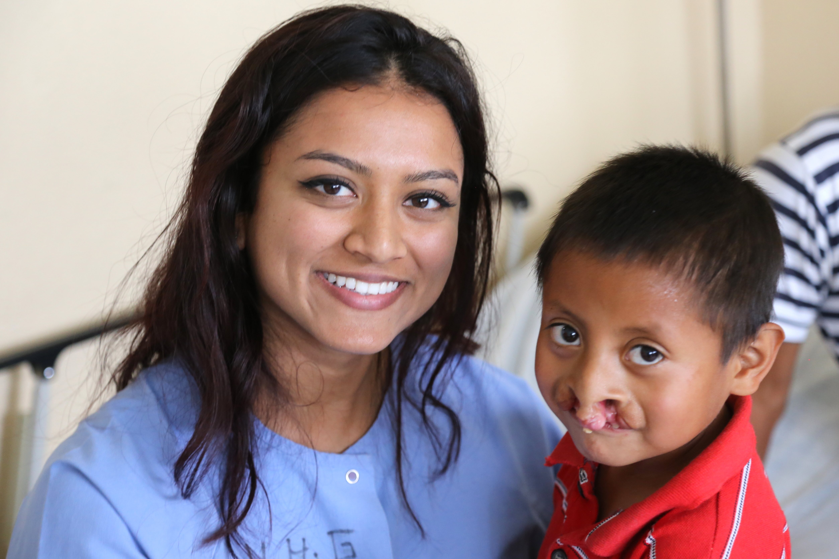

Volunteer for District 5300’s Rotaplast Mission
Lima, Peru
May 21-June 3, 2017
VOLUNTEER INTEREST FORM

Rotarians from District 5300 will be needed to fill five non-medical volunteer positions. Individuals interested in volunteering as medical or non-medical volunteers should review the Rotaplast website: www.rotaplast.org, fill out Rotaplast’s application form, complete this form, and return it along with a personal statement by October 16, 2016, to Roger Schulte rogerschulte@gmail.com.

Name of Interested Volunteer: |  | Name of Rotary Club:
Medical [ ] or Non-Medical [ ] | Volunteer Address:
Email: |  | Phone:

Non-medical volunteers should accompany this interest form with a short personal statement (no longer than 250 words) which addresses: Why they might be interested in joining a Rotaplast team and what skills they would bring to the team. Medical volunteers should contact Roger Schulte.

Questions: Roger Schulte: (909) 532-0673 rogerschulte@gmail.com

